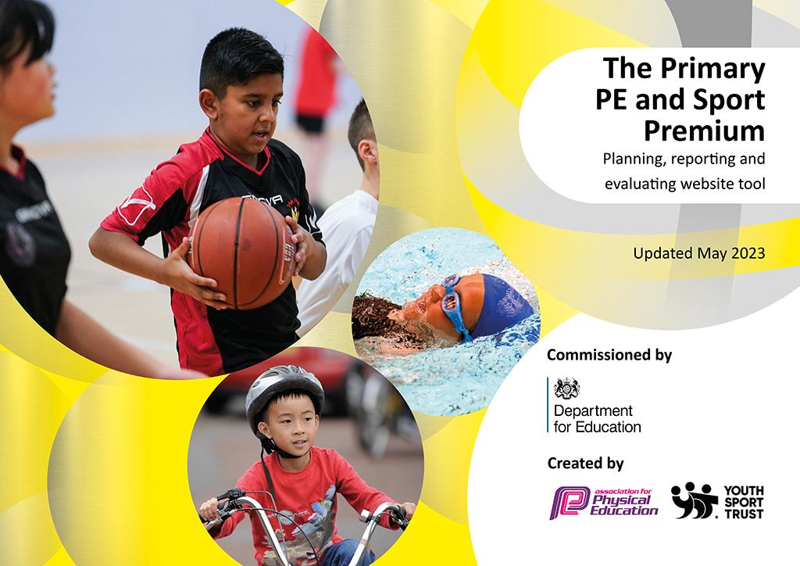
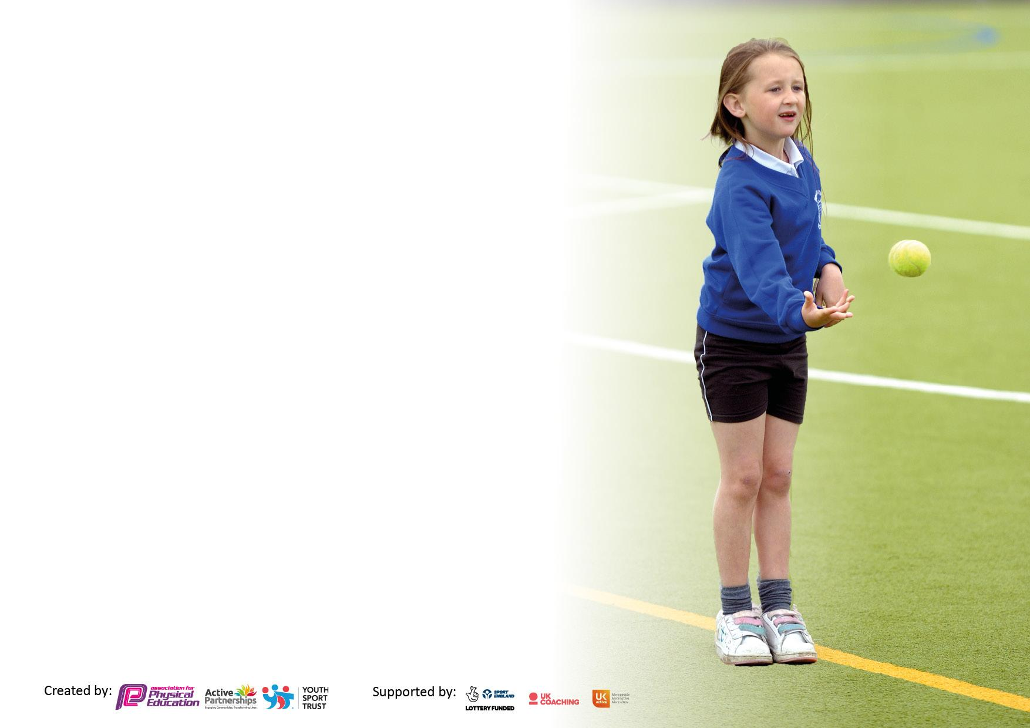

It is important that your grant is used effectively and based on school need. The Education Inspection Framework makes clear there will be a focus on ‘whether leaders and those responsible for governors all understand their respective roles and perform these in a way that enhances the effectiveness of the school’.

Under the Quality of Education Ofsted inspectors consider:
Intent - Curriculum design, coverage and appropriateness
Implementation - Curriculum delivery, Teaching (pedagogy) and Assessment
Impact - Attainment and progress

To assist schools with common transferable language this template has been developed to utilise the same three headings which should make your plans easily transferable between working documents.

Schools must use the funding to make additional and sustainable improvements to the quality of Physical Education, School Sport and Physical Activity (PESSPA) they offer. This means that you should use the Primary PE and sport premium to:

- Develop or add to the PESSPA activities that your school already offer
- Build capacity and capability within the school to ensure that improvements made now will benefit pupils joining the school in future years
- The Primary PE and sport premium should not be used to fund capital spend projects; the school’s budget should fund these.

Pleasevisitgov.ukfortherevisedDfEguidanceincludingthe5keyindicatorsacrosswhichschoolsshoulddemonstrate animprovement.Thisdocumentwillhelpyoutoreviewyourprovisionandtoreportyourspend.DfEencouragesschools to use this template as an effective way of meeting the reporting requirements of the Primary PE and Sport Premium.

We recommend you start by reflecting on the impact of current provision and reviewing the previous spend.

Schools are required to publish details of how they spend this funding, including any under-spend from 2021/2022, as well as on the impact it has on pupils’ PE and sport participation and attainment. All funding must be spent by 31st July 2023.

We recommend regularly updating the table and publishing it on your website throughout the year. This evidences your ongoing self-evaluation of how you are using the funding to secure maximum, sustainable impact. Final copy must be posted on your website by the end of the academic year and no later than the 31st July 2023. To see an example of how to complete the table please click HERE.
Details with regard to funding
Please complete the table below.

Total amount carried over from 2021/22 | £
Total amount allocated for 2021/22 | £
How much (if any) do you intend to carry over from this total fund into 2022/23? | £
Total amount allocated for 2022/23 | £
Total amount of funding for 2023/24. To be spent and reported on by 31st July 2023. | £ 24,440
Swimming Data
Please report on your Swimming Data below.

Meeting national curriculum requirements for swimming and water safety.

N.B. Complete this section to your best ability. For example you might have practised safe self-rescue techniques on dry land which you can then transfer to the pool when school swimming restarts.
Due to exceptional circumstances priority should be given to ensuring that pupils can perform safe self rescue even if they do not fully meet the first two requirements of the NC programme of study
What percentage of your current Year 6 cohort swim competently, confidently and proficiently over a distance of at least 25 metres?  N.B. Even though your pupils may swim in another year please report on their attainment on leaving primary school at the end of the summer term 2022.  Please see note above | 75%
What percentage of your current Year 6 cohort use a range of strokes effectively [for example, front crawl, backstroke and breaststroke]?  Please see note above | 50%
What percentage of your current Year 6 cohort perform safe self-rescue in different water-based situations? | 75%
Schools can choose to use the Primary PE and sport premium to provide additional provision for swimming but this must be for activity over and above the national curriculum requirements. Have you used it in this way? | Yes -30 pupils from Year 6 who had not met the KS2 expectation had an intensive week of top up swimming May 2023 £1000. Following the week 50% of those attending had met the KS2 expectation.

Action Plan and Budget Tracking
Capture your intended annual spend against the 5 key indicators. Clarify the success criteria and evidence of impact that you intend to measure to evaluate for pupils today and for the future.

Academic Year: 2022/23 | Total fund allocated: | Date Updated: July2023
Key indicator 1: The engagement of all pupils in regular physical activity – Chief Medical Officers guidelines recommend that primary school pupils undertake at least 30 minutes of physical activity a day in school |  |  |  | Percentage of total allocation:
 |  |  |  | %
Intent | Implementation |  | Impact
Your school focus should be clear what you want the pupils to know and be able to do and about  what they need to learn and to  consolidate through practice: | Make sure your actions to achieve are linked to your intentions: | Funding allocated: | Evidence of impact: what do pupils now know and what can they now do? What has changed?: | Sustainability and suggested next steps:
To encourage active learning across the curriculum. | - Purchase 5-a-day-tv with parent access.  - Active learning identified as non-negotiable within the curriculum  - Daily Mile introduced across the school. | £334 | 5-a-day used in class and in breakfast club daily. Active Learning opportunities identified  as non negotiable within curriculum.  Daily Mile successfully relaunched throughout the school | Share other online resources with staff eg Go Noodle, Active Learning
To provide opportunities for physical activities out of school hours. | - Pupil voice to find out what other clubs they would like.  - Look at outside providers to see what other opportunities we can offer or signpost to.  - Develop cultural capital opportunities within the club offer. |  | Range of outside providers running clubs. Technique Soccer, Gymnastics, Tennis, Irish Dancing, Drama, School based clubs: cooking club, rugby, cricket, country/maypole dancing | Clubs remain popular across the school but will be a focus in 2023/24 targeting the clubs we feel the children need to enhance their education further.
To ensure there are sufficient resources to allow pupils to be active in PESS. | - Audit and top up resources  as necessary.  - Equipment monitors in post.  - Staff reminders about looking after equipment. | £2,301 | Additional balls and equipment purchased to ensure adequate stock to enable staff to deliver high quality lessons.  Sport Premium funding used to subsidise club places for those who are in need and willbenefit. | Natural wear and tear of equipment will mean some additional spend each year.  Monitors and staff vigilance will help maintain equipment.
Pupils identify cycling as a healthy way to enjoy leisure time. By the end of KS1 most pupils can ride on 2 wheels. By the end of KS2 pupils are becoming more confident cyclists on the road. | - EYFS/KS1 pedal free week – October 2022  - Year 4 Level 1 Bikeability –January 2023  - Year 5 – Bikeability – April 2023 | £3105 | Cycling - This year we have continued the focus on cycling to again catch up after the pandemic.  The current Year 6 did the Level 2 Bikeability in June 2022 and now some are regularly riding to school and using the new cycle shelter on the KS2 playground. Year 5 did Level 2 in April -they will now be ready to cycle to school in September if they are ready. EYFS and KS1 have completed Pedal Free and there are more pupils now riding on 2 wheels. As a school we have maintained our bikes and helmets to enable them to develop their skills further. Year 4 completed Level 1 in January so will be ready for Level 2 next year. We have used Sport Premium funding to subsidise and support this and feel ,as an important life skill, it is a good use of the funding. | Staff have knowledge of the strategies used so would be able to lead some cycle training in KS1  Updated and well maintained school fleet ensures we can continue to develop this.  Investment in cycle/scooter storage ensures we can maintain this focus.
Key indicator 2: The profile of PESSPA being raised across the school as a tool for whole school improvement |  |  |  | Percentage of total allocation:
 |  |  |  | %
Intent | Implementation |  | Impact
Your school focus should be clear what you want the pupils to know and be able to do and about  what they need to learn and to  consolidate through practice: | Make sure your actions to achieve are linked to your intentions: | Funding allocated: | Evidence of impact: what do pupils now know and what can they now do? What has changed?: | Sustainability and suggested next steps:
Provide responsibilities for Year 6 pupils that develop independence and skills that will help with secondary transition. | - Year 6 responsibilities awarded and pupils in post.  - Playground buddies to be introduced | £50 | Pupils in post and ready to take on new challenges. | Sports Captains to help run parent/child events and promote benefits of being physically active.
To ensure staff have access to the latest resources to support the promotion of PESS. | - Membership of Youth Sport Trust  - Subscription to PE Hub | £525 | Latest information available and shared with staff to enable them to take on board new initiatives and promote physical activity in class. | Staff have a wealth of knowledge and are able to share expertise within the staff team.
Ensure PE lead is proactive in making changes and adaptations to the curriculum to suit pupils at Great Chart primary School | - Attend Kent and Medway PE conference.  - PE lead release to work on curriculum development and quality of teaching  - Develop the progression documentation to ensure an effective curriculum with golden threads identified. | £800 | Attendance at the PE conference ensures most current information within PESS and also provides opportunities to develop and try new activities and strategies.  Development of Golden Threads through the subject in place and ready to embed across the curriculum. | If funding is not available PE lead can connect with other local schools to share ideas and support.
Profile of PESS to remain high through communication channels. | - Use of weekly Bulletin, newsletter and Class Dojo to share pictures and information about PESS |  | The introduction of Class Dojo has enabled staff to share more of the wider curriculum , including PESS, with photos and information. | We will continue to use Class Dojo to share a window into the school day.

Key indicator 3: Increased confidence, knowledge and skills of all staff in teaching PE and sport |  |  |  | Percentage of total allocation:
 |  |  |  | %
Intent | Implementation |  | Impact
Your school focus should be clear | Make sure your actions to | Funding | Evidence of impact: what do | Sustainability and suggested
what you want the pupils to know | achieve are linked to your | allocated: | pupils now know and what | next steps:
and be able to do and about | intentions: |  | can they now do? What has
what they need to learn and to |  |  | changed?:
consolidate through practice:
To upskill staff to provide high quality teaching and learning across the curriculum. | - PE conference for PE lead  - Provide staff with a wide range of resources to help increase physical activity across the curriculum.  - Monitor skills and progression of pupils through assessment and lesson observations.  - Develop the tennis skills of pupils from Years 1 -6  - Link golden threads to school values. | £1400  £425 | Tennis - We continue a link with Bethersden Tennis Club to provide tennis sessions for pupils from Yr 1 -6. This has enabled staff to learn teaching techniques and activities and for pupils to further develop their skills. As a school we have again invested in the equipment to continue this provision if the funding were to stop. There was also an opportunity for pupils in Years 2 and 3 to experience further coaching in an after school club in Terms 1-4  Cricket - Year 2 and Year 6 had the opportunity for half a term of free cricket sessions through Kent Cricket Club. This was part of Chance to Shine and a coach came weekly to teach them the skills to play Rapid Fire Cricket. He also linked all activities to our school values, which was great. As a result children have played in class and we have had some KS1 taster sessions to develop their interest further.  PE Hub: Staff are able to access progressive plans for a range of activities to ensure a high quality experience for pupils.  Curriculum development:  The curriculum update has ensured the golden threads of head, heart and hands enables pupils to identify the range of skills that they can develop through high quality PESS. This includes physical skills, social/emotional skills and cognitive/thinking skills.  They are also closely linked to the school values that permeate the curriculum. | We have invested in equipment to ensure staff would be able to continue to teach tennis if sessions were no longer available.  Golden threads ensure pupils and staff are more aware of the knowledge and skills that PESS provides opportunities for.
Key indicator 4: Broader experience of a range of sports and activities offered to all pupils |  |  |  | Percentage of total allocation:
Intent | Implementation |  | Impact
Your school focus should be clear | Make sure your actions to | Funding | Evidence of impact: what do | Sustainability and suggested
what you want the pupils to know | achieve are linked to your | allocated: | pupils now know and what | next steps:
and be able to do and about | intentions: |  | can they now do? What has
what they need to learn and to |  |  | changed?:
consolidate through practice:
To engage pupils with outdoor learning through Forest School Activities. | - Forest school sessions booked through Onodrim.  - Further develop outdoor learning opportunities across the curriculum.  - Staff use forest school ideas in other areas of the curriculum. | £8225 | Forest School - This year we have extended the forest school provision using Sport Premium funding. All pupils now access sessions once a term enabling them to work outside in the different seasons. Learning outside of the classroom in this way is a benefit to both mental and physical health and is always very popular with pupils. This year we have also had the addition of ‘Dodger’ the forest school dog who has been great at teaching pupils how to behave around animals. | As a school we have invested in a new forest school area, that is growing and developing so that should we no longer have funding we would still be able to provide sessions.
To learn new life skills that will benefit pupils in wider society | - First Aid training for all pupils.  - Year 6 cookery sessions as part of life skills.  - Wellbeing days 3 x a year highlight the importance of healthy body/healthy mind. | £1400 | First Aid - In January 2023 we welcomed Rhona from FAB First Aid to Great Chart Primary School. She worked with all pupils from EYFS - Yr 6 teaching them basic first aid and teaching them the basics of CPR. Learning to keep themselves healthy is part of the PE curriculum and another important life skill. It also fits nicely with the announcement that all schools will have a defibrillator in the next year.  Wellbeing days- pupils look at the 6 ways to wellbeing which includes keeping healthy. Pupils explore fitness activities and walks in the local area.
To enable more pupils to swim 25m by the end of KS2 | - Book top ups for Year 6 Term 6 | £1000 | 30 pupils from Year 6 were invited to attend top ups. These were the 30 pupils who had not met the end of KS2 requirement.  Of those an additional 15 pupils met the expected standard following their week of top ups.  75% of pupils in Year 6 have met the end of KS expectation of 25m+

Key indicator 5: Increased participation in competitive sport |  |  |  | Percentage of total allocation:
 |  |  |  | %
Intent | Implementation |  | Impact
Your school focus should be clear | Make sure your actions to | Funding | Evidence of impact: what do | Sustainability and suggested
what you want the pupils to know | achieve are linked to your | allocated: | pupils now know and what | next steps:
and be able to do and about | intentions: |  | can they now do? What has
what they need to learn and to |  |  | changed?:
consolidate through practice:
To enable and encourage pupils to compete in both intra and inter competitions. | - School Games package  - Ashford District Sports Association  - Competition entries/transport | £315 | Competition - Although the PE provision and after school clubs have grown, competition with other schools has not really taken off again yet. The local School Games Co-ordinator is at Lenham school and transport has been a barrier to more events.  The school Council asked for a school football team and this is something we have been able to organise. Mr Bagsaw and Mr Eason (Glodwell) have run trials and selected a team that will represent the school in the Football League next season. They have organised training sessions and will be quite competitive.
Additional Achievements:

Swimming - We are really pleased to have restarted the swimming programme following the pandemic and closure of the Stour Centre. This has had a huge impact on the number of pupils who can swim and meet the end of KS requirement of 25m. In terms 1 and 2 Year 4 went swimming. Due to the high numbers of non swimmers we decided to send 1 class at a time for more intense 45 min sessions. This has been a really effective way for swimming to be provided and improvements could clearly be seen. In Terms 3 and 4 Year 3 went swimming. Around 70% non swimmers.
In Terms 5 and 6 Year 5 have been swimming and we are awaiting the assessment data, but similarly less than 50% of pupils can swim 25m.

Future spending:
- The key document ‘ Evidencing the PE Premium’ is being updated and will be on the school website before the end of July.
- Daily Mile -Autumn relaunch
- Encourage and promote competition both intra and inter school.
- Encourage parent/child physical activity sessions.
- Embed the new curriculum.

Signed off by
Head Teacher:
Date:
Subject Leader:
Date:
Governor:
Date:

